GCS 135
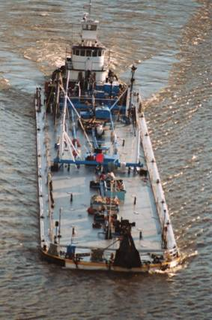

TYPE: Tank Barge – Coiled
OFFICIAL NO: 523392
HULL NO: 189
PORT OF REGISTRY: New York, NY
ABS CLASS: + A-1 Oil Barge
BUILT : 1969
GROSS TONNAGE: 2168
DIMENSIONS: LOA – 300’
Breadth 43’ 3”
Depth 19’3”
Draft load line manned 14’ 8 ¾”
Draft load line unmanned 15’ 8 ¼”
BUILDER: Gretna Machine & Iron Works
GRADE: Grade B & lower
CAPACITY: 36,278 Bbls @ 100%
CARGO PUMPS: Two (2) Byron Jackson, 2143 Bbls per hour each
CARGO PUMP ENGINES: Two (2) GM Detroit Diesel, 8V-71
OVERFILL PROTECTION: Conrad Bergen Dual Stick w/o audible
ANCHOR: One (1) 2000Lbs. x 1 3/8” wire 105 fathoms
AIR DRAFT: 54’ above baseline (top of kingposts)
HOSE MANIFOLDS: Four (4) – two aft, two mid-ships
NOTCH DEPTH: 4”
GENERATORS: Two (2) – one Lister, one Isuzo
CARGO TANKS: Five (5) Port & Starboard – Ten (10) Compartments
Three (3) 7400 Bbls Each
Two (2) 7000 Bbls Each
CARGO HOSE CAPACITY: Four (4) aft manifold, Four (4) Midship Manifold

